Vendor Performance and Inventory Optimization Report
1. Executive Summary
This report provides a data-driven analysis of vendor performance, brand profitability, and inventory efficiency to optimize sales and inventory management. The key findings indicate a significant dependence on the top 10 vendors (contributing $65.69\%$ of procurement spend) and a clear inverse relationship between purchase quantity and unit cost, confirming the benefits of bulk buying. Critically, we identified a significant difference in profitability between high-sales and low-sales vendors, with low-performing vendors exhibiting higher mean profit margins ($41.57\%$) than top vendors ($31.18\%$). This suggests top vendors may rely on volume over margin. The analysis also pinpoints high-margin, low-volume brands that are ideal targets for promotional campaigns.

2. Business Problem and Objective
Business Problem
Effective inventory and sales management are critical for optimizing profitability in the retail and wholesale industry. The company is at risk of incurring losses due to inefficient pricing, poor inventory turnover, and high vendor dependency.
Project Objectives
The goal of this analysis is to:
- Identify underperforming brands that require promotional or pricing adjustments.
- Determine top vendors contributing to sales and gross profit.
- Analyze the impact of bulk purchasing on unit costs.
- Assess inventory turnover to reduce holding costs and improve efficiency.
- Investigate the profitability variance between high-performing and low-performing vendors.

3. Research Questions and Analysis
The analysis was structured around four core research questions to address the business objectives:
# | Research Question | Analysis Focus
RQ 1 | Which brands require promotional or pricing adjustments? | Identifying low-volume brands with high-profit margins.
RQ 2 | Which vendors contribute most to procurement and total profit? | Vendor concentration and total purchase dollar contribution.
RQ 3 | Does bulk purchasing effectively reduce unit costs? | Correlation between TotalPurchaseQuantity and unitpurchaseprice.
RQ 4 | Is there a significant difference in profitability between top-performing and low-performing vendors? | Two-Sample T-Test on ProfitMargin between vendor groups.

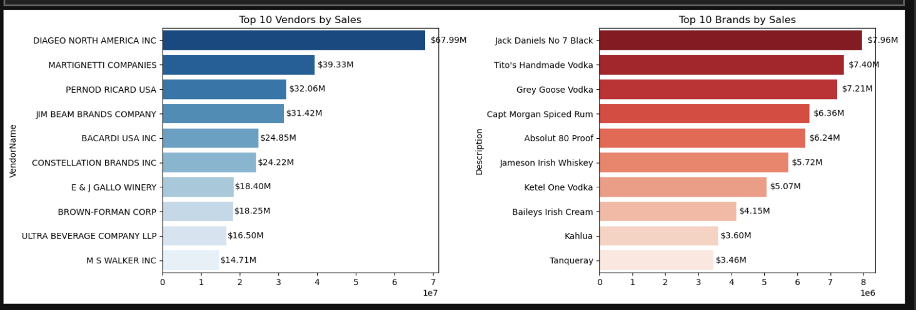
4. Key Findings and Interpretations
4.1. Which brands require promotional or pricing adjustments? (RQ 1)
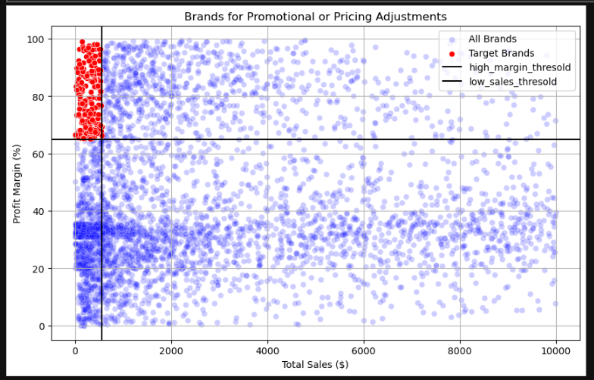
The scatterplot highlights a set of brands with very high profit margins but extremely low sales. These brands represent an immediate opportunity for revenue growth. By promoting these brands strategically, the company can rapidly increase profits without increasing operational costs. The remaining brands fall across performance quadrants that help guide decisions about pricing, promotions, renegotiations, or discontinuation.

This scatterplot compares Total Sales ($) on the X-axis and Profit Margin (%) on the Y-axis for all brands. The chart also includes two threshold lines:
- Vertical Line → Low Sales Threshold
- Horizontal Line → High Margin Threshold
The red points represent Target Brands (brands flagged for action).

Key Insights
1. The red cluster shows brands with:
- Very low sales (far left of the chart)
- Very high profit margins (70%–100%)
Interpretation
These are high-margin but low-sales brands.
This means:
- The business makes excellent profit per unit sold.
- But not enough customers are buying them.
These brands are perfect candidates for promotion, awareness campaigns, pricing adjustments, or placement improvements.
Business Action
✔ Promote them more
✔ Improve visibility on shelves
✔ Bundle offers, small discounts
✔ Educate sales teams about their high profitability
Increasing sales even slightly will significantly increase total profit.

2. The large blue area shows scattered performance of all remaining brands
Many brands have:
- Moderate to high sales
- Wider range of profitability (0–100%)
Interpretation
Brand performance is diverse, and different strategies are required:
Low margin + high sales area
- Popular products
- But margins are thin
➡ These may need pricing optimization or cost negotiation with vendors.
High margin + high sales area
- Strong performers
➡ These are the brands to prioritize and protect.

3. The thresholds help segment brands into 4 strategic zones
Quadrant A: Low Sales, High Margin (Red Zone)
r highlighted target brands
➡ High profit potential but poor movement
➡ Ideal for promotional push

Quadrant B: High Sales, High Margin
➡ Best performers
➡ Maintain stock, invest in visibility, consider exclusive vendor relationships
Quadrant C: Low Sales, Low Margin
➡ Not profitable and not moving
➡ Candidates for phasing out or renegotiating vendor terms
Quadrant D: High Sales, Low Margin
➡ Good demand but poor profit
➡ Negotiate lower purchase cost or adjust pricing

Inventory and Promotion Strategy
Analysis:
The average Stock Turnover rate was calculated to understand how efficiently inventory is moving. A specific group of brands was then identified using two criteria:
- Brands with low sales, defined as being below the 15th percentile (less than $560.30), and
- Brands with a high profit margin, defined as being above the 85th percentile (greater than 64.97%).
These brands are important because they are highly profitable but not generating enough sales, making them strong candidates for promotional or pricing strategies.
Visualization:
Inference:
- Stock Turnover: The average stock turnover is 1.71, with most brands turning over less than twice per period. This low rate suggests the company is holding a high volume of slow-moving inventory, which increases warehousing and carrying costs.
- Promotion Targets: A target list of brands (e.g., 'Absolut Orient Apple Vodka', '12 Days of Pearls Gift Set') was identified. These products possess a strong, high margin but lack sales volume.
- Strategic Insight: These high-margin, low-volume products are perfect candidates for targeted promotional campaigns to boost sales volume without severely eroding the inherent profitability.

4.2. Vendor Procurement Dependency (RQ 2)
Analysis: Vendors were ranked by TotalPurchaseDollars to calculate their procurement contribution.
Visualization:
Inference:
- High Dependency: The top 10 vendors account for 65.69% of the total procurement spend. This concentration indicates a high level of vendor dependency, which could pose a risk if sourcing from any of these top partners is disrupted.
- Top Contributor: DIAGEO NORTH AMERICA INC. is the single largest vendor, leading in both total purchase dollars and overall gross profit, demonstrating its critical role in the supply chain.
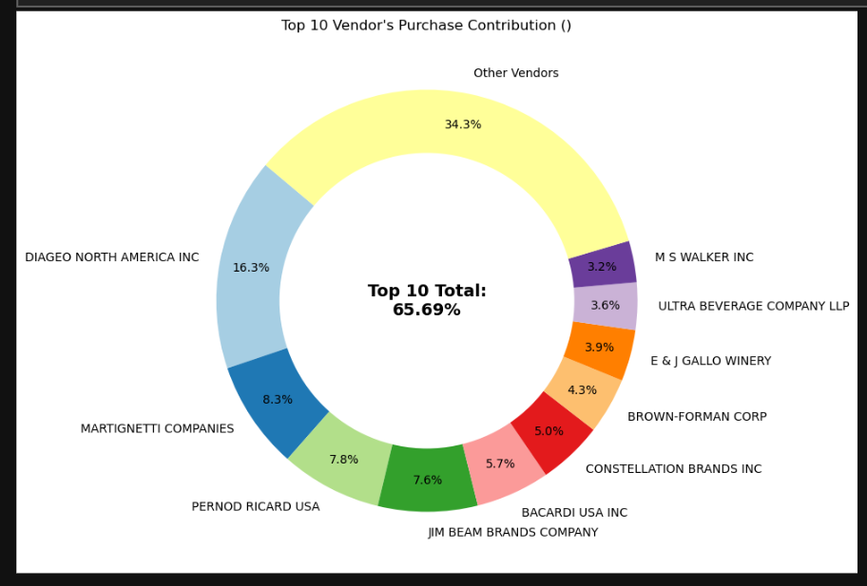

4.3. Impact of Bulk Purchasing on Unit Cost (RQ 3)
Analysis: The relationship between a brand's total purchased quantity and its average unit purchase price was investigated.
Visualization:
Inference:
- Clear Inverse Relationship: The scatter plot reveals a strong negative correlation between the logarithm of TotalPurchaseQuantity and the logarithm of unitpurchaseprice.
- Cost Savings Confirmed: This finding validates the business strategy of volume purchasing: as the quantity purchased increases, the unit purchase price reliably decreases. This is a critical cost-saving mechanism for the company.
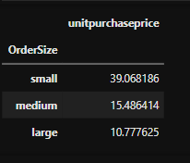

- Vendors buying in bulk (Large Order Size) get the lowest unit price ($10.78 per unit), meaning higher margins if they can manage inventory efficiently.
- The price difference between Small and Large orders is substantial (-72% reduction in unit cost)
- This suggests that bulk pricing strategies successfully encourage vendors to purchase in larger volumes, leading to higher overall sales despite lower per-unit revenue.

4.4. Profitability Variance Analysis (RQ 4)
Analysis: A Two-Sample T-Test was performed to compare the ProfitMargin between top-performing vendors (high sales) and low-performing vendors (low sales).
Visualization:
Inference (Statistical):
- Hypothesis Test Result: The T-Statistic was -11.67, with a P-Value of 0.0000.
- Conclusion: The Null Hypothesis is rejected. There is a significant statistical difference in profit margins between the two vendor groups.
- Interpretation:
- Top Vendors 95% CI: (30.74, 31.61), Mean: 31.18
- Low Vendors 95% CI: (40.50, 42.64), Mean: 41.57

- Strategic Insight: Low-performing vendors, despite low volume, are selling products with significantly higher margins. High-performing vendors may be relying on low-margin, high-volume products for their market dominance.

5. Recommendations
Based on the analytical findings, the following recommendations are proposed:
- Vendor Risk Management: Develop a contingency plan for the top 10 vendors (who control 65.69%of procurement) to mitigate supply chain risk. Explore opportunities for negotiation with these top vendors to optimize pricing further, leveraging their volume contribution.
- Strategic Promotions: Implement targeted marketing and sales promotions for the identified list of High-Margin, Low-Sales Brands (e.g., 'A Bichot Merc Champs M', 'Woodford Rsv Master Coll Pnt'). The goal is to convert high potential margin into actual gross profit by driving volume.
- Optimize Inventory Holdings: Investigate the large number of products with low stock turnover (below 2.0). Implement strategies like mark-downs, returns, or specialized warehousing for these slow-moving items to reduce excessive inventory holding costs.
- Vendor Profitability Review: Conduct a detailed review of all top-performing vendors to understand the causes of their lower mean profit margins ($31.18). This may be acceptable due to high volume, but negotiating better cost of goods or slightly higher retail pricing could significantly impact overall revenue.

